**Executive Summary**

In this project we used three publically available data sets to try and create a model to predict housing prices in King County Washington. Many different housing and economic factors were considered for use in the final model but some were eliminated using a backwards selection technique after altering the price statistic with a log transformation. This model was then validated using several different diagnostic plots. The final model showed that many different parameters had a significant predictive impact on price and was useful. The model had an adjusted R-squared value of 81 percent showing that it accounted for a high proportion of the variance in price. It is our hope that this model would be able to be used by several different stakeholders eliminating the gap between buyers and sellers desired price to one that can be more accurately predicted. In the future we plan on continuing to grow our model by including other descriptive factors about the King County area.

**Business Problem**

The business problem that we are trying to solve is how to predict housing prices in King County Washington. This prediction will use many different factors related to the properties of a house including number of floors, square footage, age of the house, city, number of bedrooms, etc. which was gathered from house sales in the area between May 2014 and 2015. The model will also use statistics about the area including average household income and tax returns per household in the zip code from the same time period. This problem will have major implications for real estate agents trying to set a selling price for a home and individuals who are trying to buy or sell a home. This model will also make home buyers and sellers aware of key parameters that will affect housing prices that will make people aware of certain factors that they previously had not considered in the home buying process.

**Data Sources**

Housing data used for the development for this model was downloaded from a Kaggle data set as a csv file containing 21613 rows and 21 columns. The economic data was then gathered from a free federal government zip code data base as a csv file with 81831 rows and 20 columns. Finally, cities and their respective zip codes were gathered from the capital impact government gateway site. Several steps were then taken to clean the data so it could be used in the model.

1. The housing and economic data sets were combined by merging at the zip code.
2. One zip code was identified as having null values for total house wages so this value was included based off of data taken from a separate United States Zip Code database.
3. 177 duplicate house ids were found and only the most recent entry remained in the data set.
4. The “View” variable was dropped because no explanation was available for this entry.
5. The necessary variables were converted to categorical.
6. The city associated to a city was added by combing the datasets.
7. Columns for average household income and average household tax returns were created.

A complete description of all the variables that were used in the model is included in Appendix A.

**Descriptive Statistics**

Before we began our analysis we started by looking at some of the descriptive statistics of values that would be used in the model. This included looking at the summary of variables within the code. An example of this output is shown in Appendix B. This output showed us information about the mean and quartiles of the data giving us a better idea of how the data looked. We then decided to look at the distributions of the independent variables to see if any necessary transformations were apparent. The distributions are also shown in Appendix B. Finally, we decided to look at the impact of some of the categorical variables on the price. This was done in order to determine if any of these different factors, waterfront, renovate, grade, or city, would show a significant difference between housing prices. The output we gathered, shown in Appendix B, made it clear that each of the categories caused a change in price.

**Analysis Approach**

The first step in our analysis approach was to test for any multicollinearity that may have been present in the model. We looked at both the numeric correlations as well as a visual representation of the correlations, seen in Appendix C, to determine which of the factors could be deemed as extraneous to the model. After performing this analysis, we were able to determine that bathrooms, grade, sqft_above, and sqft_living15 had a correlation of over 0.7 with another predictor variable and therefore were not needed in the completion of the final model.

After determining what variables, we would want to use in our model the next step was to perform exploratory data analysis on the price variable to decide if any transformation was needed. After looking at the histogram of the price variable we observed that it was very heavily right skewed. With this information we decided to apply a log transformation to the variable in order to make the data appear more normal by redefining the column in the dataset. This transformation was effective and the log of the price was used for the target variable in the model. A visualization of the histograms of price and the log of price is included in Appendix D.

The next step we needed to undertake was building the regression model to predict the log of housing prices. The first step was to separate the data into two different groups, the training and test sets. This was done by placing 75 percent of the data into the training set and the reaming 25 percent into the test set. Both sets were then validated to be normal by looking at the histograms of each of the two distributions. The training set was used to build the model and determine its coefficients. Finally, the test set was used to validate the created model, checking its overall accuracy. As inputs into the model we included the necessary continuous and categorical variables as well as several important interaction terms. Not all interactions were considered as they were deemed beforehand to be unnecessary or nonsensical. Examples of interactions that were considered include: lot size and waterfront, square footage and number of bedrooms, conditions and age, etc. Dummy variables were also created to replace the categorical variables, as they had no numeric value associated with them. This allowed the model to be created and easily managed. After running the initial model several variables were not found to have any significant predicting power on the price and were therefore taken out of the model entirely. Using backwards selection, we were able to remove the insignificant predictors and increase our overall model accuracy. These insignificant predictors were found by looking at their respective P-values and seeing if they were greater than our 0.05 alpha level.

While building the model we also began looking at influential observations and outliers. We plotted a Cook’s distance half normal plot and identified a high leverage point. On closer examination we found that exceptionally high lot size and square foot living had significant effects on the regression line. Re-running the model after the removal of the exceptional predictor two other influential points were identified. We iterated on the model one last time after removing the above mentioned points causing the Cook’s distance not to exceed 0.008 which is well within the accepted range. Following this analysis, a final model was created and a screenshot of all the significant predictive terms and their respective model coefficients is included in Appendix E.

Our final piece of analysis to validate the model was to look at the necessary diagnostic plots. No pattern was present in the residual plot and they appeared to be normal meaning no assumptions were violated. The QQ plot also gave us some interesting insights on the model performance. The plot showed that there was deviation on the tails but the followed the 45-degree line towards the middle which points to the fact that this might be a Cauchy distribution. This also shows that a regression spline will probably be a better fit for our data and will lead to less bias in the model. The final validation in our analysis was to look at both the normal and adjusted R-squared values. The adjusted R-Squared value of our training set was 80.88 percent and the R-squared value of the test set was 80.91 percent, indicating that a large proportion of the variance in the log of price can be explained by the model parameters.

**Model Results**

As stated above, the results of the model building can be found in Appendix E. These results show that there is a relationship between the log of the price and several different predictors that we have collected data from. In the image the significant predictors are indicated with ***. 29 different variables had an impact on the log of price of which 6 are continuous, 20 are categorical, and 2 are interaction terms. Their impact on the change in price can be seen by looking at the value in the estimate column. When looking at an individual variable, in this case sqft_living, an increase of one extra square foot would result in an increase in the price by 4.9149E-4 percent, given that all other variables are held constant. Similarly, for other continuous parameters without interaction effects, a change by 1 unit will correspond to a change in the percentage of the price by the estimate value. If there is an interaction term, like with sqft_living, the sum of the estimates is used to determine the percentage change. These changes are again computed with all other parameters being held constant.

Some of the possible limitations of the model are seen when looking at the QQ plot, seen in Appendix F. It is clear that when the predicted price is low the model tends to underestimate the expected price of the house. Similarly, when the price of the house is large our model overestimates the expected price. This means that our model is not the best at predicting houses that should be in the extreme price ranges. This could be amended in the future by looking at other factors related to the area of the listing such as, crime rates, school districts, or proximity to major points of interest.

**Implication of Results**

This model has many implications for both professional relators and individual consumers. We have shown that there are many factors about a house that have a significant impact on the price. This means that for a consumer they will no longer have to wonder if the price that has been listed for a house is close to the actual value. For a seller, they will no longer have to worry about listing their house for too little a price and worry about a loss of money. Finally, a relator will be able to sell houses more quickly because they will not have to spend as much time on price negotiations as both parties will have good information about a reasonable expected price. This will ultimately result in a fairer housing market where everyone will know more about pricing of property and the individual aspects of their homes that add value. For competitors, it will become more difficult to try and sell houses at increased prices if customers are more aware of the true value of a home. The final implication of our model is that it is built on historical data. This means that as more houses are sold and more information about the areas economics or other factors are gathered, the accuracy of the model will increase. This could potentially eliminate the over and under estimating of prices and create an even more accurate model.

**Conclusion**

Housing markets carry a lot of inherent uncertainty within themselves and has always difficult for various stakeholders to extract the accurate valuation of the house incorporating myriads of related variables. With our model, home owners can leverage the power of analytics to have more detailed information about the price of a home. This protects interests of both buyers and sellers by ensuring they get a fair estimate of their price and are not cheated by one another.

**References**

Zip Code Data: http://www.ciclt.net/sn/clt/capitolimpact/gw_ziplist.aspx?ClientCode=capitolimpact&State=wa&StName=Washington&StFIPS=53&FIPS=53033

Area Code 98052 Data: http://www.unitedstateszipcodes.org/98052/

Kings County Housing Data: https://www.kaggle.com/harlfoxem/housesalesprediction/

Economic Data: http://federalgovernmentzipcodes.us/

**Appendix A**-Description of variables to be used in the model.

|  |  |
| --- | --- |
| **Variable name** | **Variable definition** |
| id | House id |
| date | The date as of which a property's value is estimated. |
| price | Value of the property |
| bedrooms | Number of bedrooms |
| bathrooms | Number of bathrooms |
| sqft_living | Square feet above + Square feet basement |
| sqft_lot | Area of house including the yard |
| floors | Number of floors |
| waterfront | Waterfront view (yes=1, no=0) |
| condition | Building Condition: Relative to age and grade. Coded 1-5. |
| 1 = Poor- Worn out. Repair and overhaul needed on painted surfaces, roofing, plumbing, heating and numerous functional inadequacies. Excessive deferred maintenance and abuse, limited value-in-use, approaching abandonment or major reconstruction; reuse or change in occupancy is imminent. Effective age is near the end of the scale regardless of the actual chronological age. |
| 2 = Fair- Badly worn. Much repair needed. Many items need refinishing or overhauling, deferred maintenance obvious, inadequate building utility and systems all shortening the life expectancy and increasing the effective age. |
| 3 = Average- Some evidence of deferred maintenance and normal obsolescence with age in that a few minor repairs are needed, along with some refinishing. All major components still functional and contributing toward an extended life expectancy. Effective age and utility is standard for like properties of its class and usage. |
| 4 = Good- No obvious maintenance required but neither is everything new. Appearance and utility are above the standard and the overall effective age will be lower than the typical property. |
| 5= Very Good- All items well maintained, many having been overhauled and repaired as they have shown signs of wear, increasing the life expectancy and lowering the effective age with little deterioration or obsolescence evident with a high degree of utility. |
| grade | Building grade- Represents the construction quality of improvements. Grades run from grade 1 to 13. Generally defined as: |
| 1-3: short of min building standards-cabin or inferior structure |
| 4: Generally older, low quality construction. Does not meet code. |
| 5: Low construction costs and workmanship. Small, simple design. |
| 6: Lowest grade currently meeting building code. Low quality materials and simple designs. |
| 7: Average grade of construction and design. Commonly seen in plats and older sub-divisions. |
| 8: Just above average in construction and design. Usually better materials in both the exterior and interior finish work. |
| 9: Better architectural design with extra interior and exterior design and quality. |
| 10: Homes of this quality generally have high quality features. Finish work is better and more design quality is seen in the floor plans. Generally, have a larger square footage. |
| 11: Custom design and higher quality finish work with added amenities of solid woods, bathroom fixtures and more luxurious options. |
| 12: Custom design and excellent builders. All materials are of the highest quality and all conveniences are present. |
| 13: Generally custom designed and built. Mansion level. Large amount of highest quality cabinet work, wood trim, marble, entry ways etc. |
| sqft_above | The living area in a house not including the basement. |
| sqft_basement | Basement area |
| yr_built | Year the house was built |
| yr_renovated | Year the house was renovated |
| zipcode | Zip code |
| lat | Latitude |
| long | Longitude |
| sqft_living15 | The average house square footage of the 15 closest houses |
| sqft_lot15 | The average lot square footage of the 15 closest houses |
| Avg_HH_Income | The average income of the household. |
| Avg_Returns | Average amount of tax return filed in household. |

**Appendix B-Descriptive Statistics**



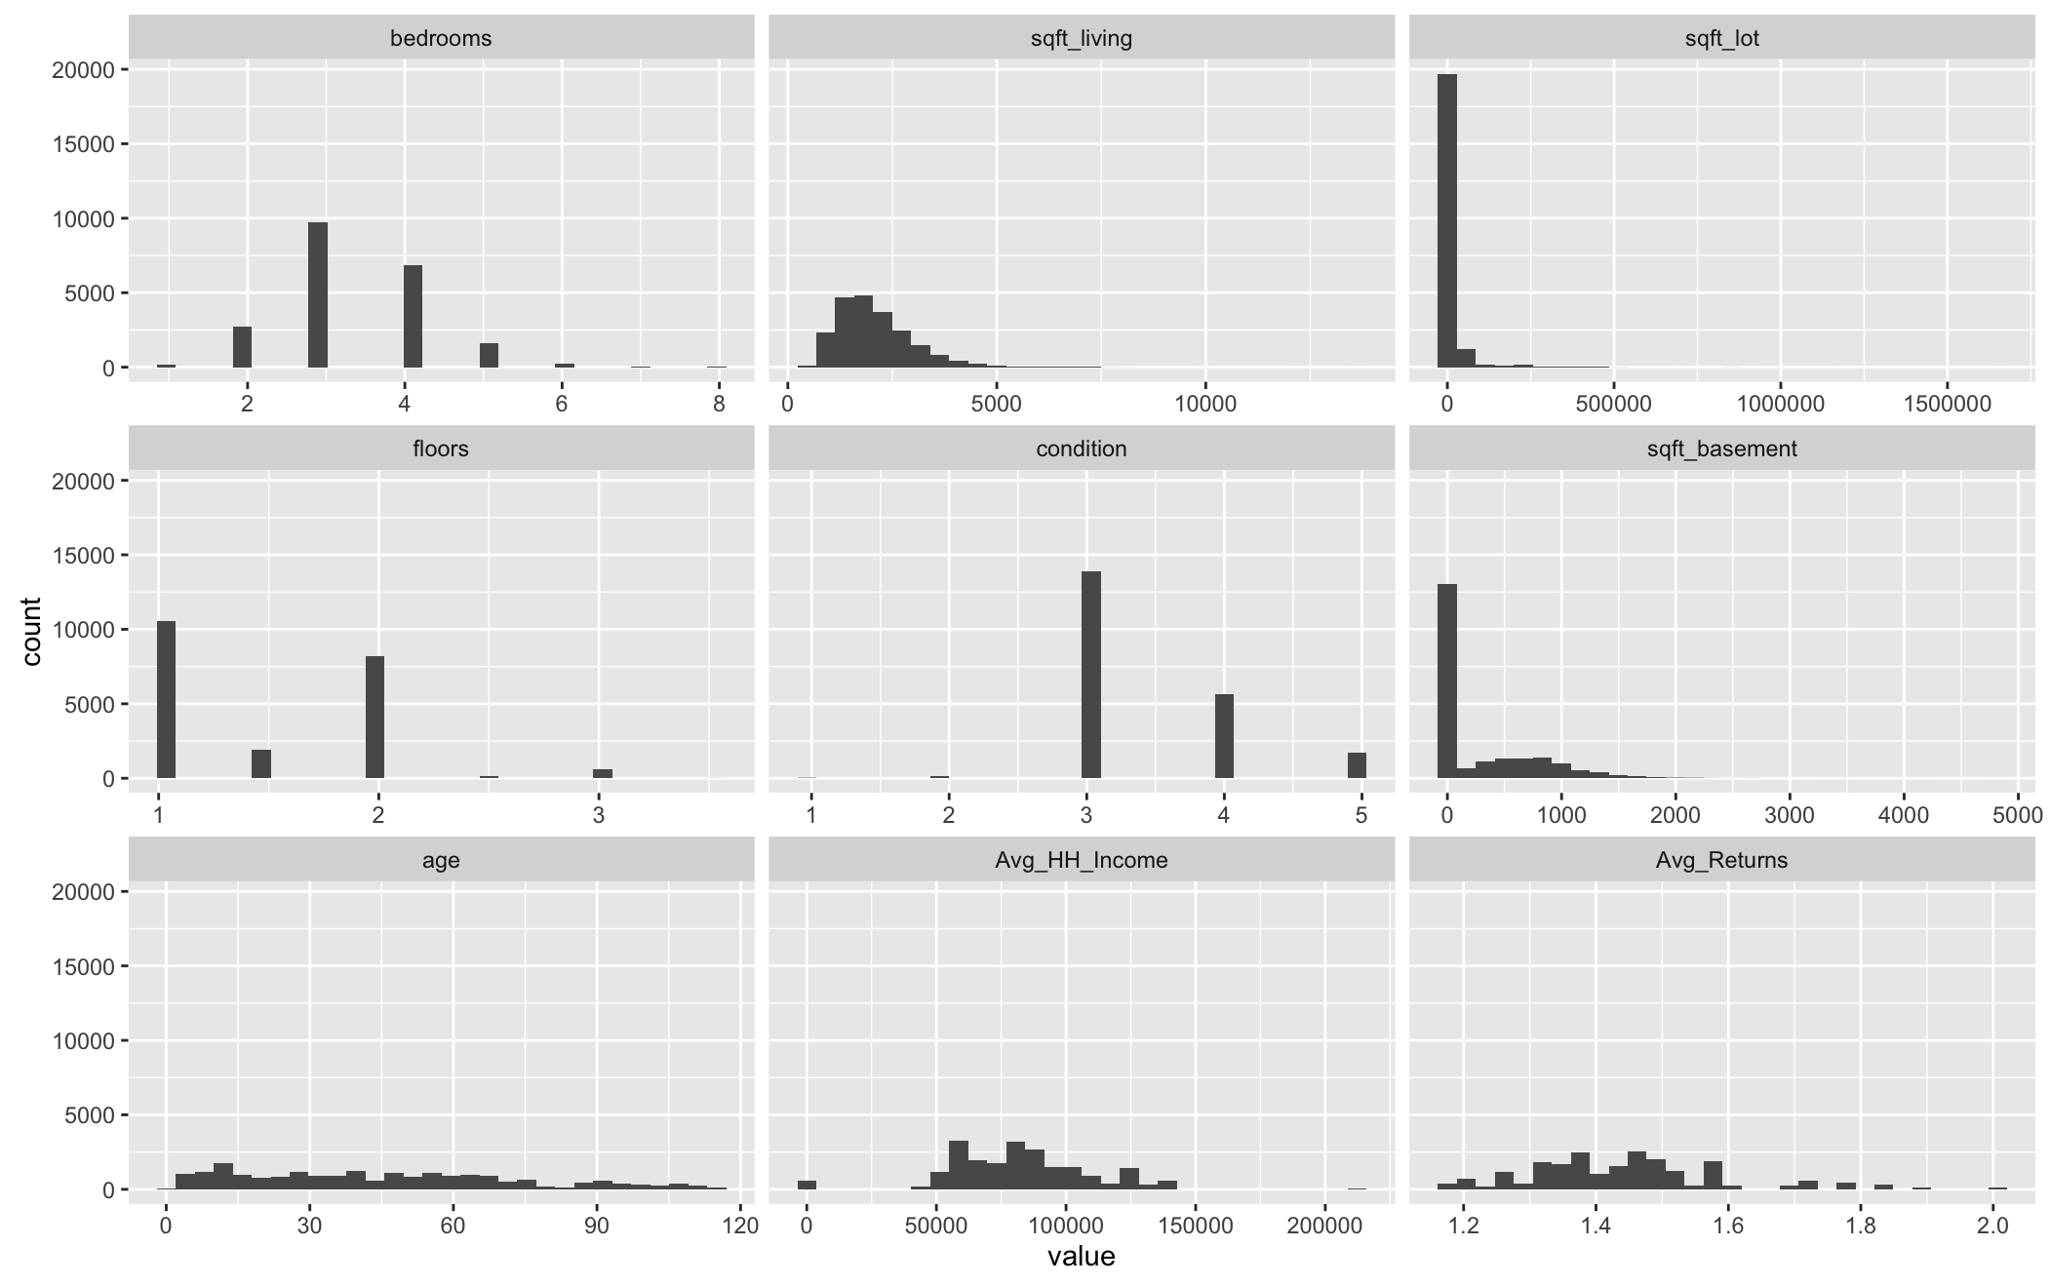

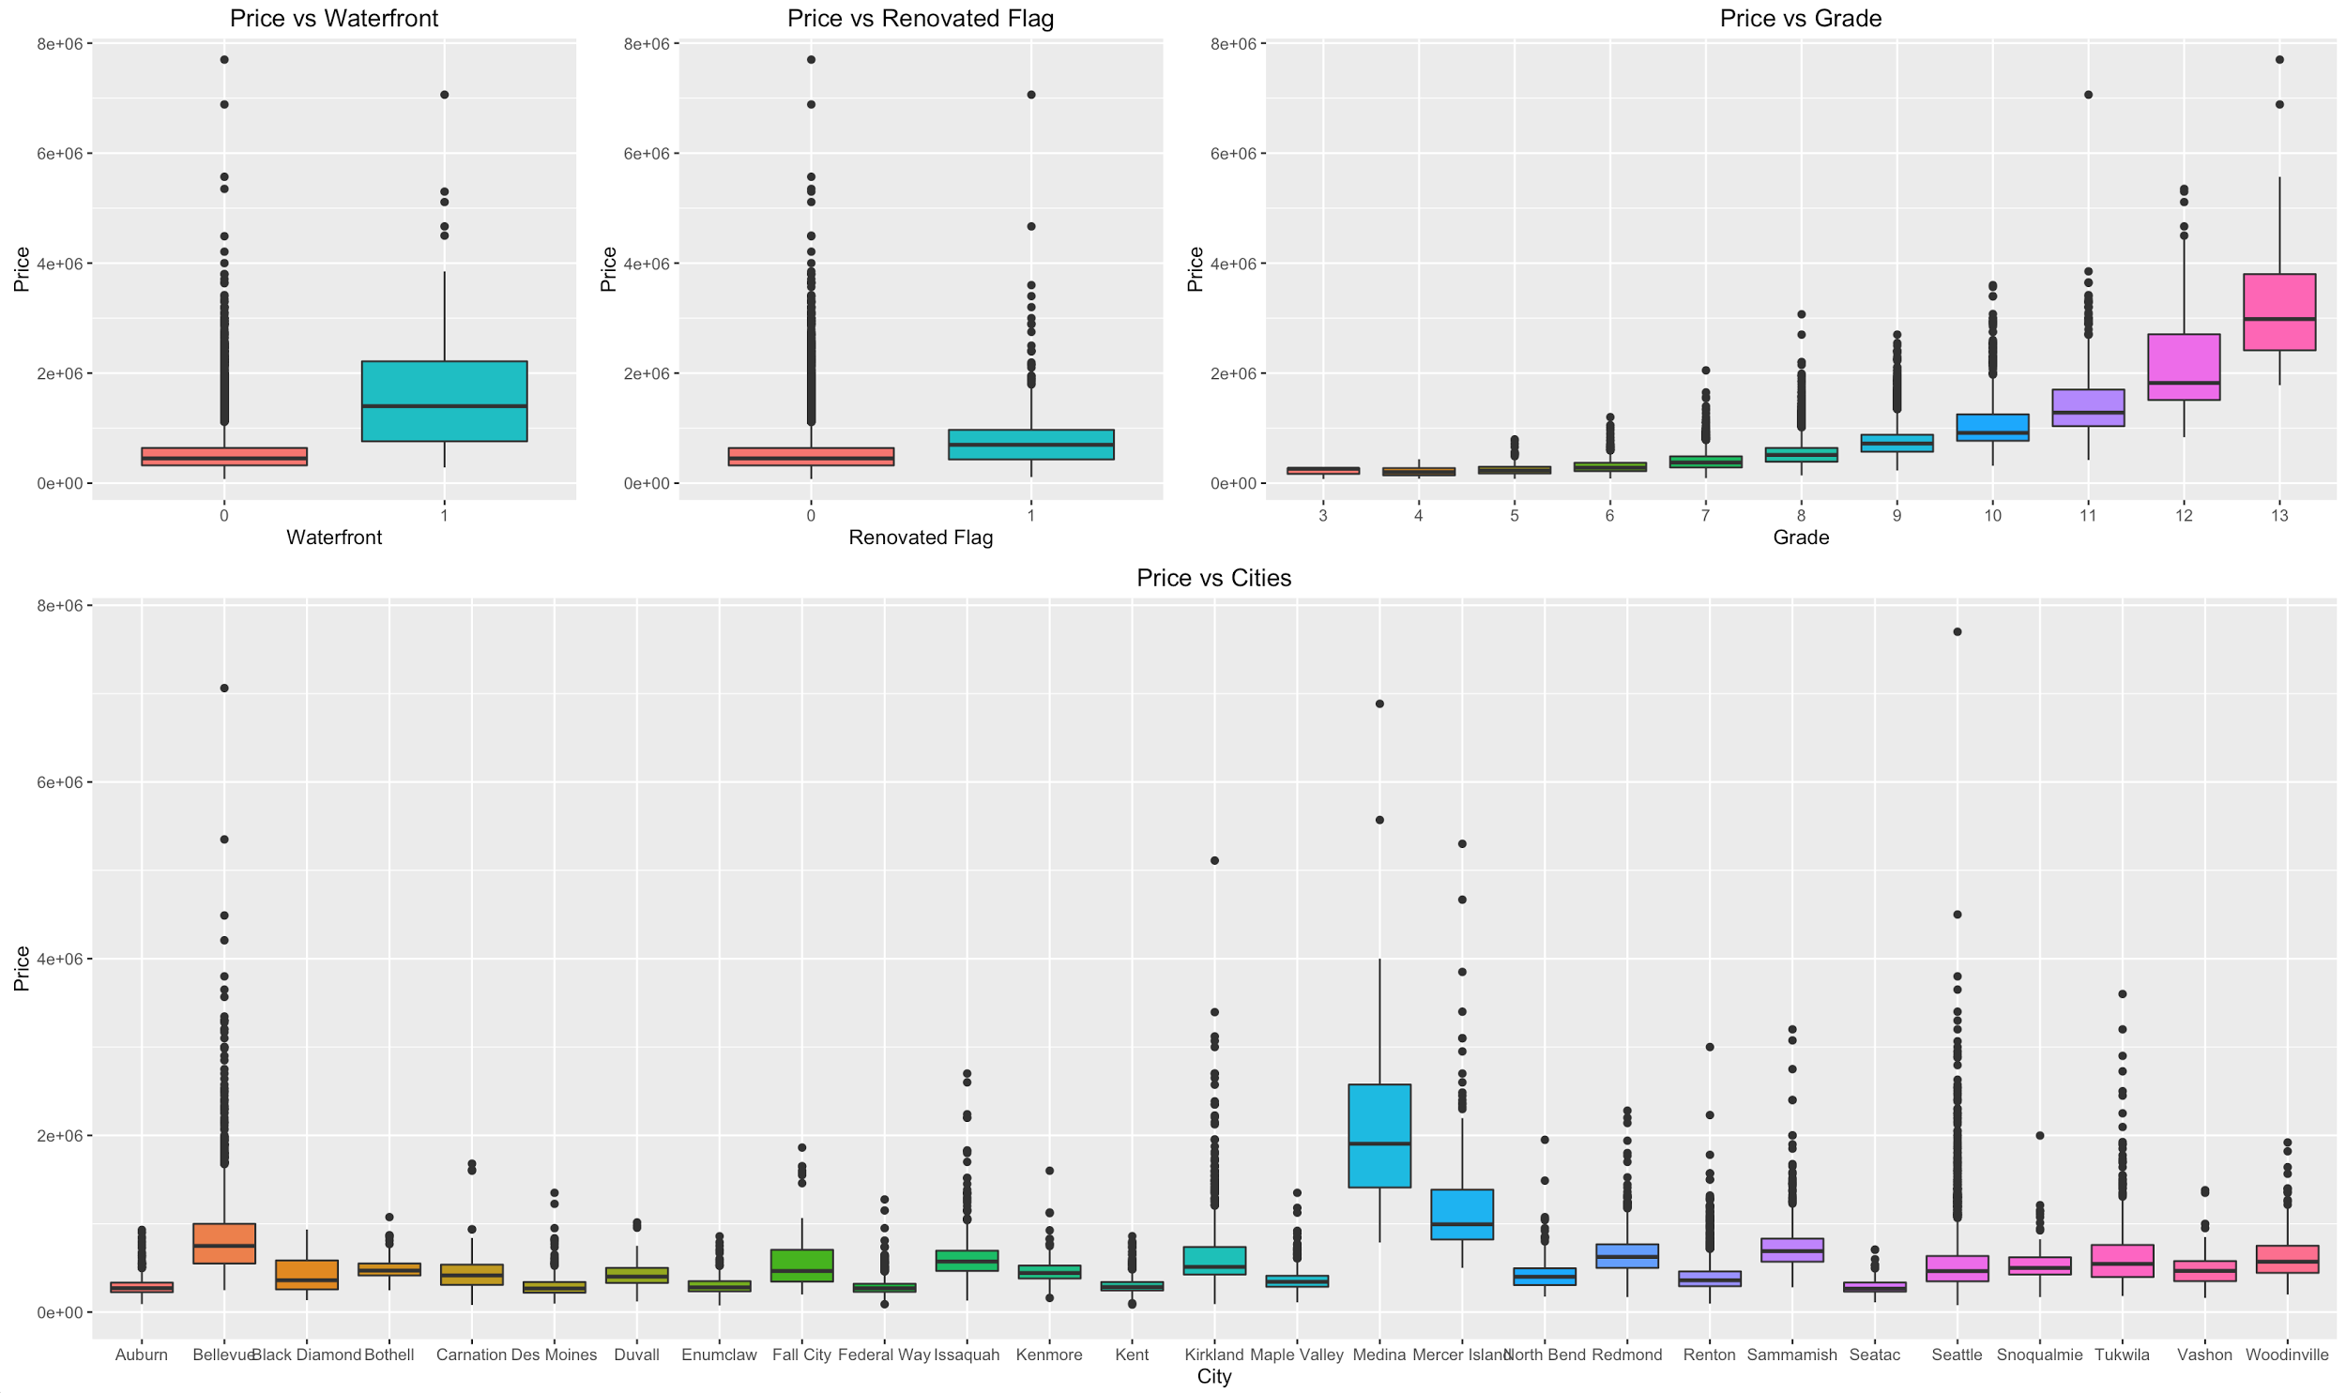

**Appendix C-**Correlations Visualised

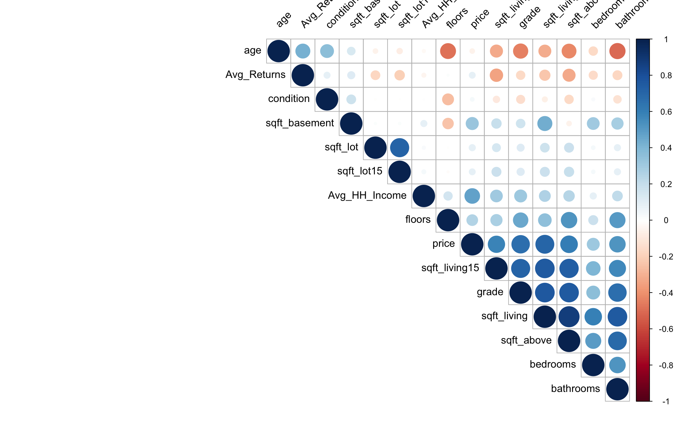

**Appendix D-**Transformations

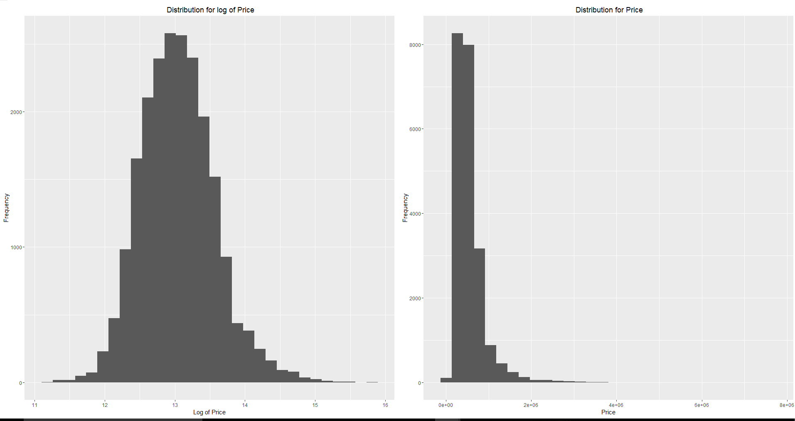

**Appendix E-**Final Model



**Appendix F-**Model Diagnostics

